How to Upload KYC Details in EPF UAN
To upload the KYC document on the EPF UAN, follow the steps mentioned below:
- Visit the EPFO’s member portal https://unifiedportal-mem.epfindia.gov.in/memberinterface/ Use your UAN and Password and fill up the Captcha to log in to the portal.

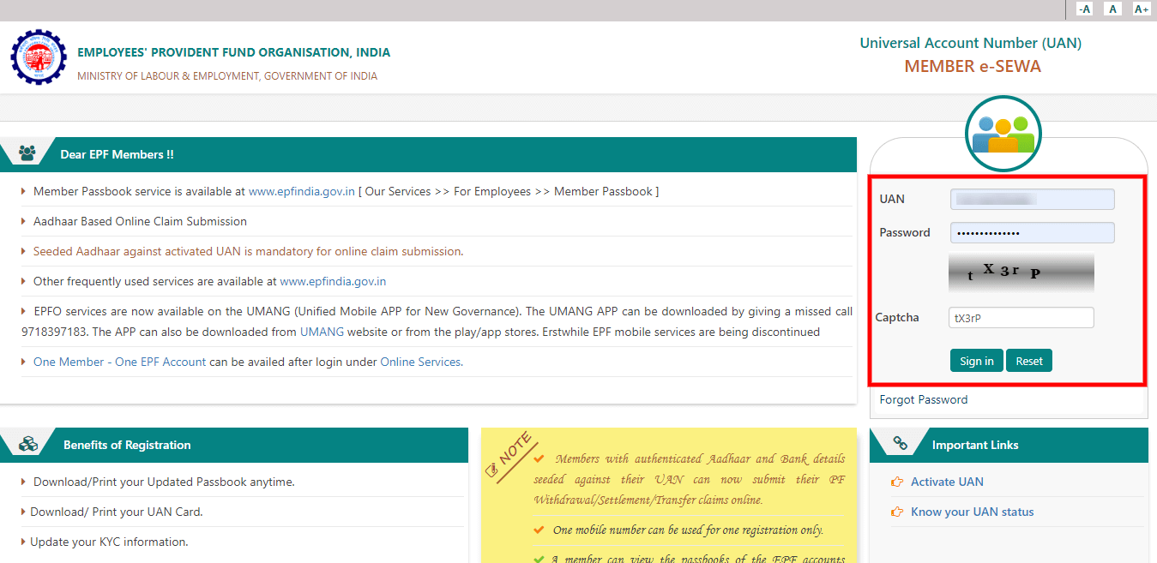

Figure 1. Visit EPFO Member Portal
- After logging in to the portal, go to the “Manage” option from the top menu bar.
- Once you have clicked on that, select the “KYC” option from the drop-down menu.
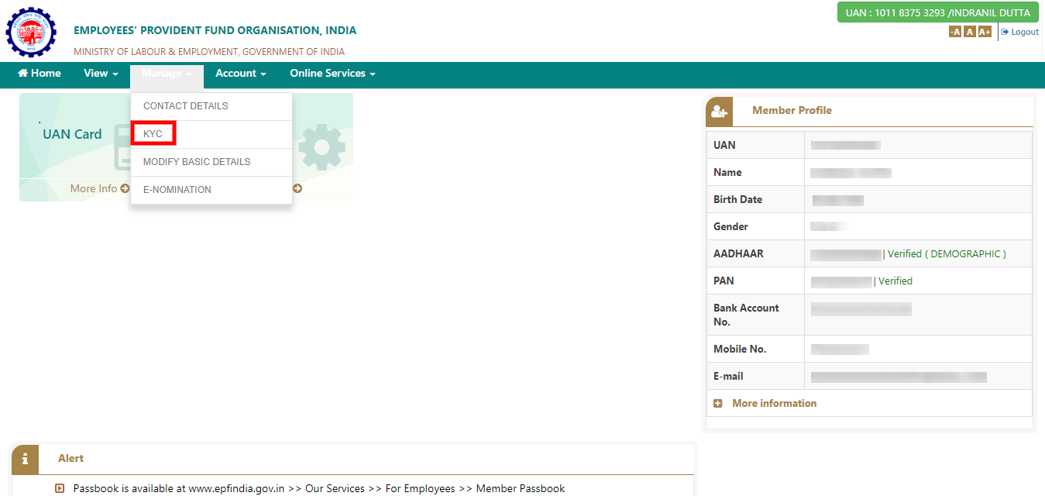

Figure 2. Selecting KYC Option
- After clicking on the “KYC” option, you will be redirected to a new page which will contain a list with different “Document Type” and respective fields next to them which are to be filled up with the details of the document.

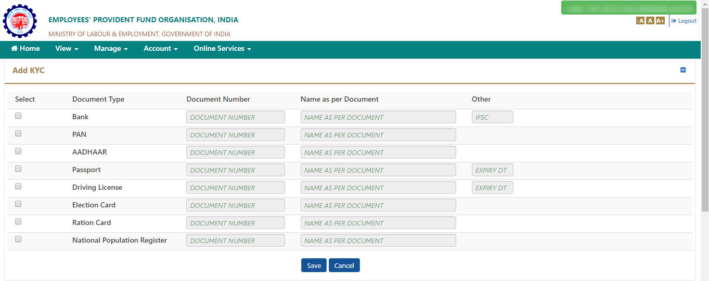

Figure 3. Filling Details
- Click on the checkbox next to the document type that you want to update and fill in the “Document Number” and “Name as per Document” fields.
- Once you have updated the details click on the “Save” option.

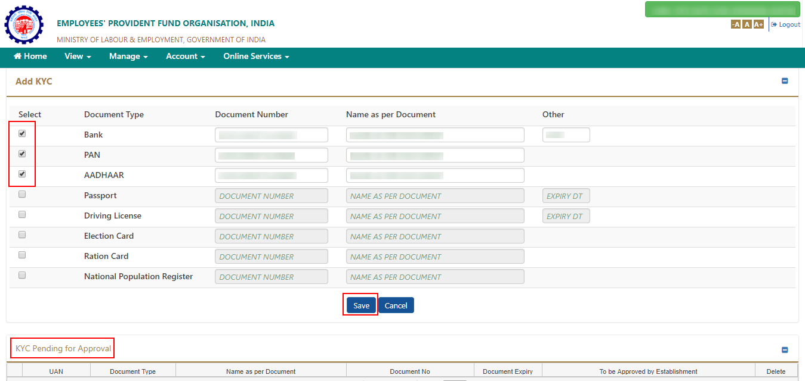

Figure 4. Status of KYC Document
- Once you have updated the details of your document, the status of your KYC document will be shown under the “KYC Pending for Approval” column. Once your employer has verified the document and approved of it, the status will be shown under the “Digitally Approved KYC.”
- Once your employer has approved your document, you will receive an SMS confirming the same.

