Step by step process for EPF UAN correction of Name, Date of Birth, Gender Online
Login to Member Interface of Unified Portal using your UAN and Password. Our article New UAN Unified Portal for Employees talks about the new UAN Unified Portal for Employees in detail.
Click on Manage>Modify Basic Details
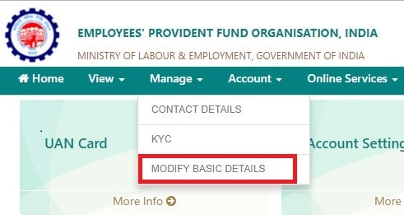
Correct Name , Date of Birth, Gender through EPF Online request
Provide the correct details as per Aadhaar (System will verify the details entered with UIDAI- Aadhaar Data)
On clicking Update Details, the request will be submitted to the employer for further approval.
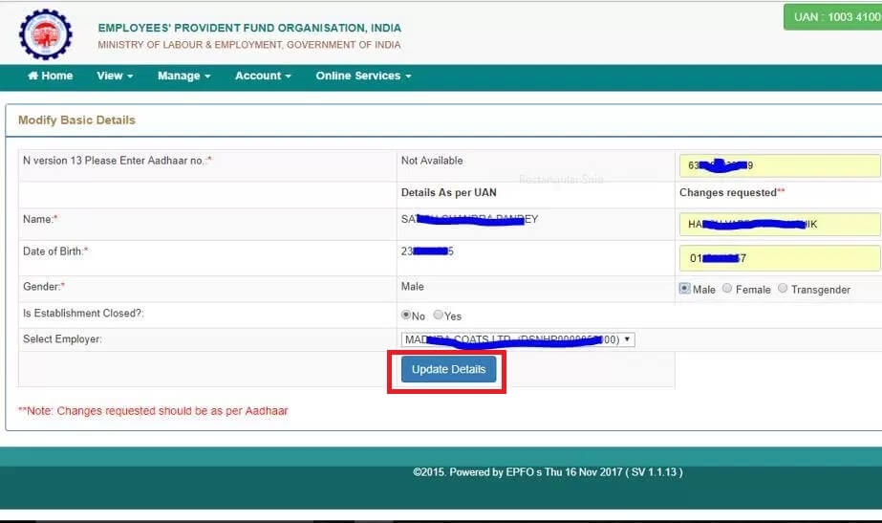Add correct details as per Aadhaar

